

Rewards
Rewards are given to pupils in line with the school values of:
- Respect
- Resilience
- Confidence
- Motivation
- Aspiration
- Integrity
In addition, pupils can gain rewards for academic achievements; involvement in enrichment activities and clubs; being a good citizen; reading and writing.
In primary, pupils receive stickers which they collect on their reward cards.
The Secondary department uses the online “ePraise” platform to record rewards. Parents and pupils can view the achievements online or via the “app”.
As a pupil’s total of stickers in primary or points in secondary grow, they receive additional incentives for their achievements as shown in the table on page 2:

Post 16
Post 16 students have access to the “ePraise” reward system.
As part of preparing for adulthood, Post 16 students also work towards intrinsic rewards that focus on the school values of Respect, Resilience, Confidence, Motivation, Aspiration, and Integrity.
All students are involved in enterprise projects which generates an income, which is then used to reward students such as paying for activities, as would happen in a work environment.
We foster that all students work together as a team and are rewarded as a team all working towards the same end goal.

PRIMARY |  | SECONDARY
Reward Type | Reasons | Reward | Reasons
 | Square Smiley Face Stickers  Given for academic achievements or demonstrating the school values. |  | Achievement Points (“APs”) via ePraise  Given for academic achievements or demonstrating the school values. These can be viewed online and spent on rewards in the shop.
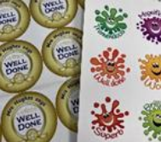 | Well Done and Smiley Splat Stickers  Awarded each time a pupil fills the square rewards Section on their card. | 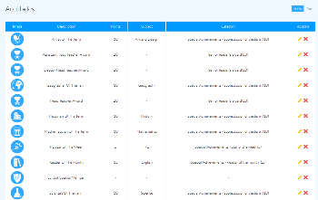 | Accolades  Badges awarded on ePraise for achievements that are “above and beyond” (such as subject pupil of the term) and for positions held within the school community (such as school council member).
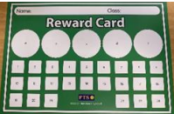 | Reward Card  Pupils stick their square and round stickers awarded below onto their card. | 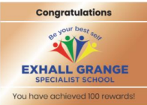 | Bronze Milestone  Appears on ePraise when pupils have achieved 100 APs.
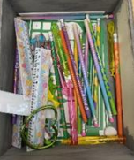 | Prize Box  When pupils have gained a circular sticker, they can choose a prize from the prize box. |  | Silver Milestone  Appears on ePraise when pupils have achieved 200 APs.
 | “You’re a star Postcard”  When pupils have gained a circular sticker, they also receive a Postcard home. | 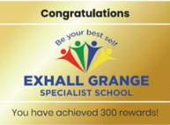 | Gold Milestone  Appears on ePraise when pupils have achieved 300 APs.
 | Completed Reward Card  When pupils have gained 5 circular stickers to fill their card, they have an extra reward of their choice such as 5 minutes extra play and take the card home. | 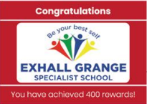 | Ruby Milestone  Appears on ePraise when pupils have achieved 400 APs.
 |  | 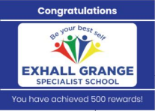 | Sapphire Milestone  Appears on ePraise when pupils have achieved 500 APs.
In the final whole school celebration assembly, the assistant headteachers announce one pupil in each year group (from year 1 to year 14) to receive the “Assistant Headteacher Enamel Badge”. This is given to the pupil in each year group whom the assistant headteachers feel have shown exemplary qualities in the school’s values. Also in the final whole school celebration assembly, the headteacher chooses select pupils from across the school to receive the headteacher’s award. |  |  | 